**Future of Electric Vehicles in India  
  
Abstract**  
In India, the demand for environmentally friendly electric cars is growing. New vehicle firms are revolutionising the automotive industry by developing revolutionary new models. The market for electric cars is quickly expanding, and with new pricing models, this expansion is expected to accelerate. All existing automobile manufacturers are aware of this shift and are working to provide new hybrid or electric vehicle models. The Indian government has promised to resolving New Delhi's air pollution problems with an ambitious strategy of converting all light duty consumer cars to electric vehicles by 2030. Developed nations such as the United Kingdom and France have announced plans to ban diesel and gasoline car sales beginning in 2040, and analysts predict that Europe's new car sales will be entirely electric five years before the deadline.  
Leading automobile manufacturers and firms in the automotive sector are increasing their commitments and rivalry. Energy experts predict that the Chinese and Indian markets would drive vehicle demand, and that electric vehicle development will be high on these nations' political agendas owing to lower carbon emission issues. As the electric car market grows, more businesses are intending to install charging stations for their vehicles.  
  
  
**INTRODUCTION:**   
   
Concerns about fuel saving and environmental protection are developing over the world, and electric vehicles are one solution.

The pace of research and development has accelerated. The global automobile sector is being disrupted by

Digitization. Increasing automation is reshaping the sector in preparation for a new revolution in the twenty-first century.

The vehicle sector in India is also feeling the repercussions. The Indian EV market is distinct from others.

Global marketplaces are important since the dynamics of the Indian economy, market requirements, and customer tastes are all changing.  
  
Understanding and renewing oneself is essential for managing future changes in this industry. These developments will alter mobility behaviour and open up new opportunities for competitiveness and collaboration. The future growth will be in providing the essential services, which are predicted to expand. Thirteen of the world's twenty most polluted cities are in India, and lowering rising levels of automobile pollution is critical. Electrification is having an impact on the automobile sector all around the world. Electric cars, including battery electric vehicles and plug-in hybrid vehicles, are expected to account for up to 50% of new vehicle sales globally by 2030.  
  
**ADOPTION OF ELECTRIC VEHICLE DRIVERS**

EV sales are rather low, and experience from other countries suggests that the correct balance of push and pull variables might determine the rate of Indian EV penetration:

1. Several nations have encouraged e-mobility adoption by offering various incentives, as well as a favourable environment with tight carbon emission rules.

2. Because a big component of the EV car cost is due to its high battery price, which impacts both manufacturing and sales, new technology may lower battery cost and boost mileage, making EVs more accessible and appealing to potential buyers.  
3. Simple, low-cost charging infrastructure for satisfying customers' daily demands.

4. Creating a pull among consumers by offering a low-cost proposition will be critical in motivating customers to invest in EVs.  
  
  
  
  
  
  
  
**OBJECTIVES**

The following are the study's aims.

1. To comprehend the trends in Indian automobile production and sales.

2. To Understand India's Emission Standards

3. To comprehend the various types of vehicle standards in various countries

4. To look into the structure of vehicle standards based on light duty vehicle energy consumption.  
  
**DATA ANALYSIS  
TABLE :1 Automobile Production Trends**

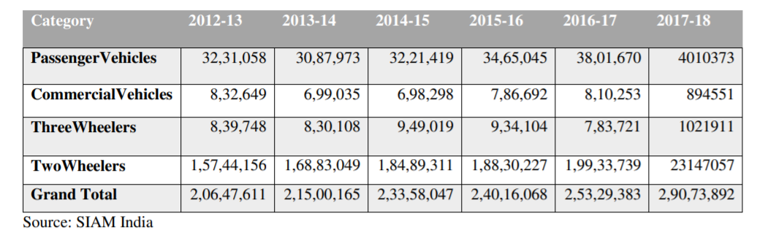  
The Indian automotive market is divided into three segments based on vehicle type: two-wheelers, commercial passenger automobiles, and others. Passenger cars and two-wheelers are the most preferred vehicles, and this category will dominate the electric vehicle industry. By 2025, the Indian passenger car sector is expected to control three-fourths of the electric vehicle market. **TABLE: 2 AUTOMOBILE DOMESTIC SALES TRENDS**  
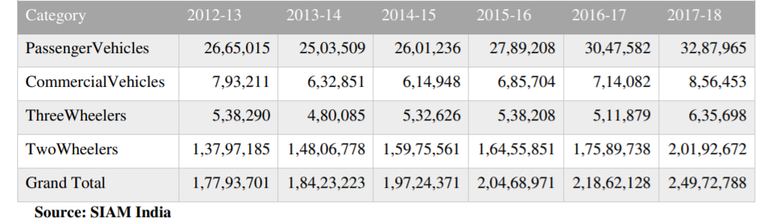  
With changes in customer tastes and environmental sustainability, the future of electric vehicle mobility is reshaping the automobile industry. A car is a networked device with enhanced intelligence for driving functions. Changing customer preferences and technology disruptors are reshaping the mobility landscape, compelling automakers to reconsider their plans and strategies.  
 **FIGURE:3 GLOBAL WARMING EMISSION REDUCTION UNDER LIGHT DUTY VEHICLE STANDARDS**.  
  
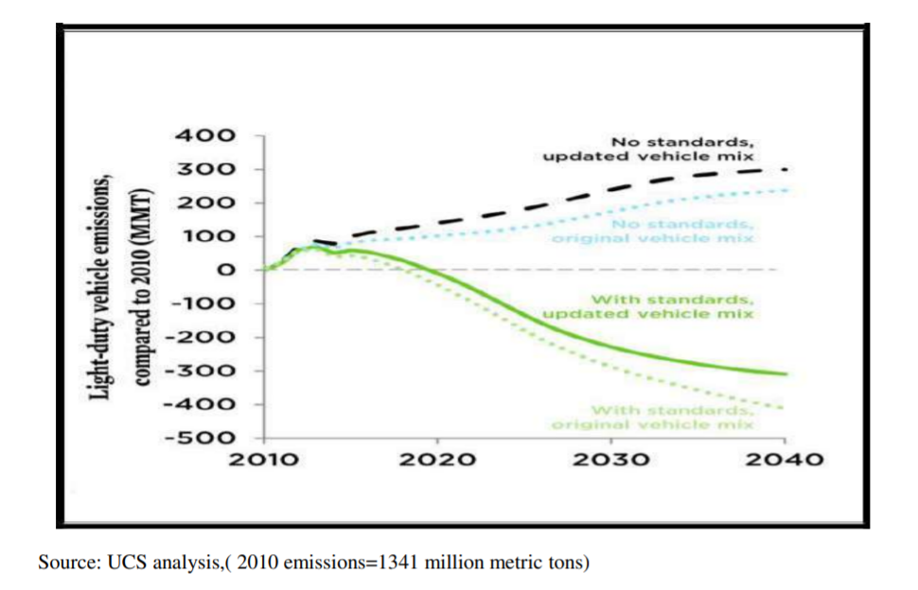  
Light-duty vehicles (LDVs) Over the previous decade, global greenhouse gas and fuel efficiency emission requirements have improved dramatically. Ten years ago, just four nations had implemented obligatory GHG emission/fuel economy criteria ( Japan, China ,South Korea, and the United States). Currently, ten additional governments (Brazil, Canada, India, Japan, Mexico, China, the European Union, Saudi Arabia, South Korea, and the United States) have set GHG emission targets. Nearly 80% of new LDVs sold globally meet GHG emission fuel economy regulations, and the aforementioned nations are among the top 15 vehicle markets in the world.  
  
**FIGURE: 4 TYPE OF BATTERY USED IN ELECTRIC VEHICLE:**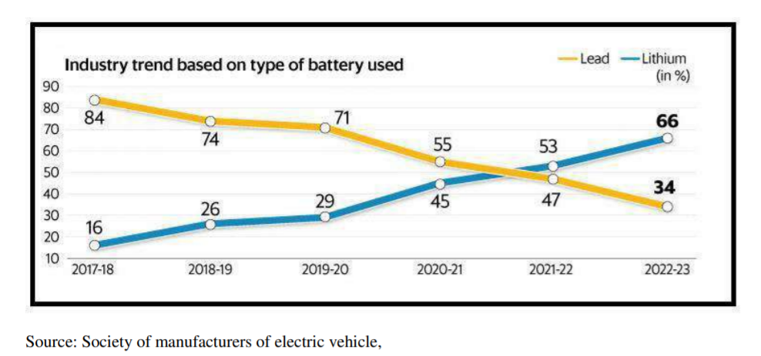Improvements in energy sources boost the value of electric vehicles by allowing them to travel farther on a single charge.

Consumers are concerned about insufficient charging facilities availability and time-consuming charging durations, which are major factors behind low electric car penetration rates. Lithium ion batteries, Lead Acid batteries, Nickel Hydride batteries, and Zebra batteries are among the batteries used in electric cars. Leadacid and lithium ion batteries are more commonly employed in the automobile industry.   
  
**ELECTRIC VEHICLE MARKET IN INDIA:**   
  
EV vehicles give a significant opportunity for smart cities to use cleaner fuel technologies in urban mobility. According to a Persistence Market Research analysis, the India electric vehicle market is expected to grow at a CAGR of 77 percent in value between 2017 and 2025. - Forecast by Vehicle Type  
The India electric vehicle market is expected to grow at a 37 percent CAGR between FY 2018 and FY2023, owing to increased government initiatives and growing consumer inclination, concerns about the harmful effects of air pollution, and massive investments by various OEMs in developing more affordable premium electric vehicles, with passenger cars and two wheelers being the main segments.- According to Technology Forecast  
Hybrid electric cars, plug-in hybrid automobiles, and battery electric vehicles are all part of the technology. Hybrid and battery electric cars are likely to dominate the market in India. Two-wheeler sales in India are predicted to account for a high market share of battery electric cars, accounting for around 85 percent in 2025.  
  
**THE WAY AHEAD FOR INDIA**

Aside from the end-user consumer, other essential stakeholders in India's shift to EVs include the government, incentives and subsidies, and the automotive value chain business.

The government contributes through creating legislation for pollution standards, fuel economy, strategic goal and direction, researching incentives and subsidies, and developing a supporting environment. The current CO2 emission goal set by the Indian government under the Paris Climate Treaty is 113 g/km by 2021. In accordance with the Corporate Average Fuel Consumption guideline, the average fuel efficiency objective for 2035 is 22 km/litre.  
  
**CONCLUSION AND FUTURE APPLICATIONS**

Electric cars are a globally sustainable mode of transportation, and their use is fast expanding. The Indian government has also begun to hasten the adoption of EVs. However, numerous obstacles must be overcome before EVs can be widely and easily adopted in India. As a new entrant in the EV transportation market, the most significant impediments identified are state government incentives and consumer characteristics. All consumers are eager to minimise pollution, but the associated expenses are too high (purchase price, minimum operating cost, vehicle cost, payback period, running cost, maintenance cost, and power cost, resale).